

SCHOOL OF

COMPUTER SCIENCE

AND IT

DEPARTMENT OF

BACHELOR OF

COMPUTER APPLICATIONS

**Introduction to Linux**

Lab Manual

**Subject Code:** 20BCA5D21

**Class:** I Year I Semester

**Prepared By:**

Suman Garai

JU2020BCAS19059

**Faculty In-Charge:**

Ananta Ojha

&

Akhil Menon

**Student Signature:**

**Faculty Signature:**

**Lab Experiment 1**: Execute the commands based on the given problem statements, referring to creating directories and file structure.

* When you are at your home directory, give command to display a long list of all files and directories including hidden ones present in ‘/usr’ directory sorted based on their modification time.

Code & Output:

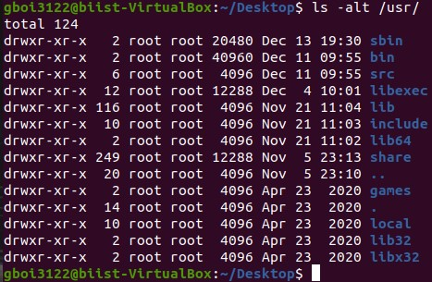

* Create a directory structure as given in Figure-1 in your home directory.

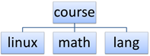

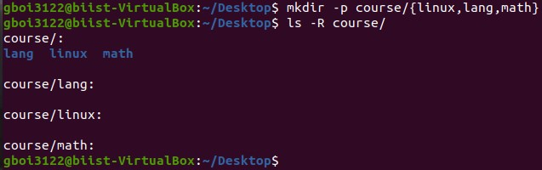Code & Output:

* Change your working directory to ‘math’ and when you are in ‘math’ give a command to display all files and directories including hidden ones present in home directory using a multi-column output.

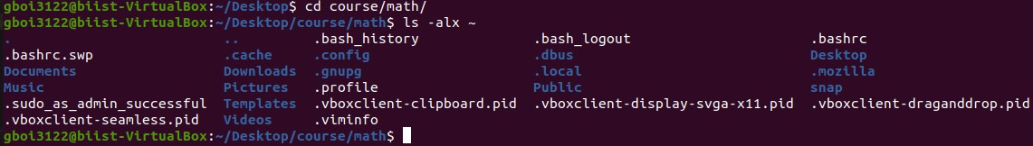Code & Output:

* Change your working directory to ‘linux’, create a file ‘first.sh’ in it. Display current logged-in users and their login time.

Code & Output:

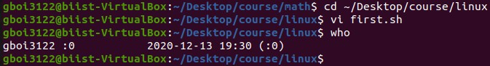

* When you are at ‘linux’ directory, create a directory structure as given in Figure-2 inside ‘math’ directory.



Code & Output:

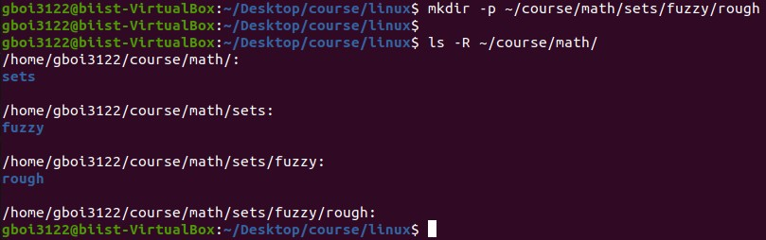

* Change your working directory to ‘math’ and remove all the three directories ‘sets’, ‘fuzzy’ and ‘rough’ using a single command.

Code & Output:



**Lab Experiment 2** **:** Execute the Commands based on creating files with pipes, wildcards using grep, sed, awk, commands.

Use a text editor of your choice to create a file ‘sales.dat’ containing the following sales data on a product. Do not include the header in the data file:

|  |  |  |  |
| --- | --- | --- | --- |
| **Product** | **Month** | **Quantity** | **Amount (Rs.)** |
| Refrigerator | June | 18 | 244500 |
| Washing Machine | August | 17 | 219500 |
| Television | July | 20 | 314000 |
| Washing Machine | September | 21 | 325700 |
| Refrigerator | September | 17 | 210000 |
| Television | October | 25 | 450000 |

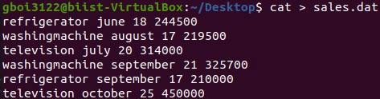

Based on the above data file, answer any two of the following questions:

* Using grep command, display sales of Washing Machine.

Code & Output:



* Using sed command, append the following data in the file.

Refrigerator October 22 320000

Code & Output:

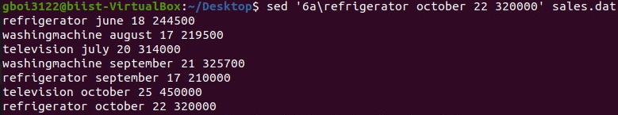

* Using awk command, display sales of July and September months.

Code & Output:



* Using grep command, display sales of all products except Television.

Code & Output:

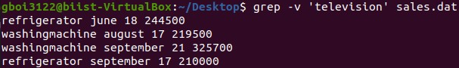

**Lab Experiment 3 :** Create a data file called ‘employee’ in the format given below:

   a. EmpCode    Character

   b. EmpName   Character

   c. Grade           Character

   d. Years of experience Numeric

   e. Basic Pay     Numeric

For example:

A001       ARJUN       E1      01      12000.00

A006           Anand         E1      01      12450.00

A010           Rajesh         E2      03      14500.00

A002           Mohan         E2      02      13000.00

A005           John             E2      01      14500.00

A009           Denial Smith E2      04      17500.00

A004           Williams      E1      01      12000.00

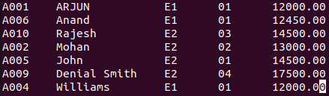

 Perform the following operations on the file:

* Sort the file on EmpCode.

Code & Output:

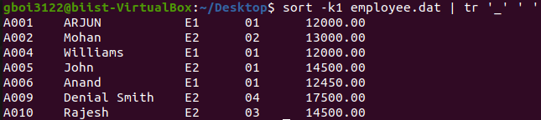

* Sort the file on: - Decreasing order of basic pay

Code & Output:

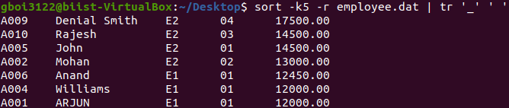

* Sort the file on: - Increasing order of years of experience

Code & Output:

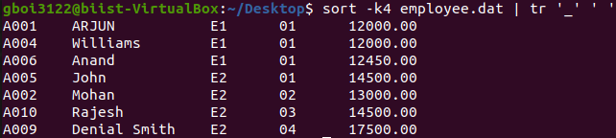

* Display the number of employees whose details are included in the file.

Code & Output:



* Display all records with ‘smith’ a part of the employee name.

Code & Output:



* Display all records with EmpName starting with ‘B’.

Code & Output:



* Display the records on employees whose grade is E2 and have work experience of 2 to 5 years.

Code & Output:



* Save the names of all employees whose basic pay is between 10000 and 15000 in a file ‘employee1’

Code & Output:

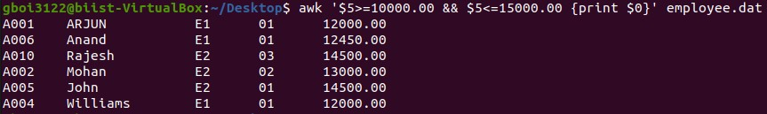

* Display records of all employees who are not in grade E2.

Code & Output:

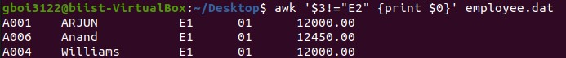

**Lab Experiment 4 :** WAP that accepts user name and reports if the user is logged in

Code:

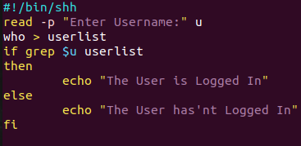

Output:

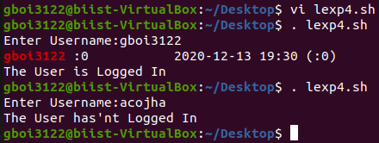

**Lab Experiment 5 :** WAP to take a file as a command-line argument and reverse the contents of the file and save it in a new file.

Code:

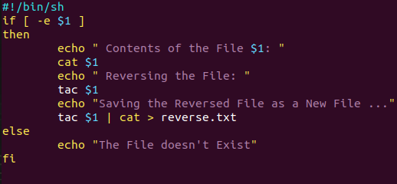

Output:

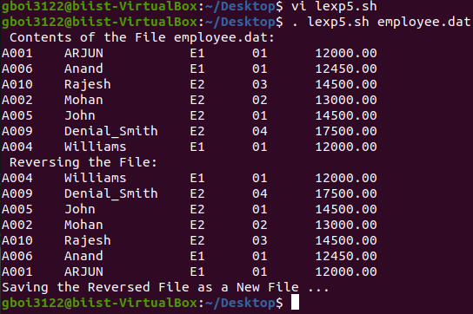

**Lab Experiment 6 :** WAP that takes a filename as input and checks if it is executable, if not make it executable.

Code:

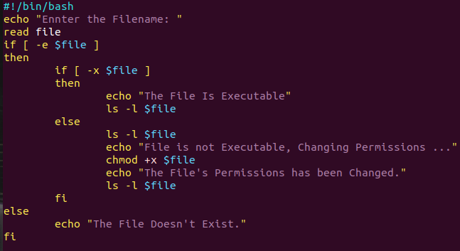

Output:

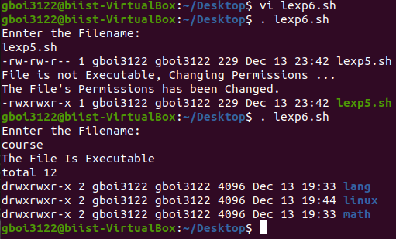

**Lab Experiment 7 :** WAP that takes a filename as input and checks if it is a directory file, if so then lists its contents.

Code:

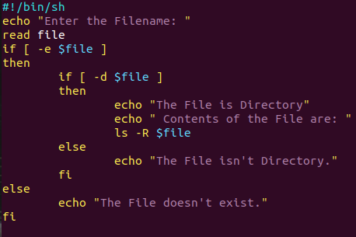

Output:

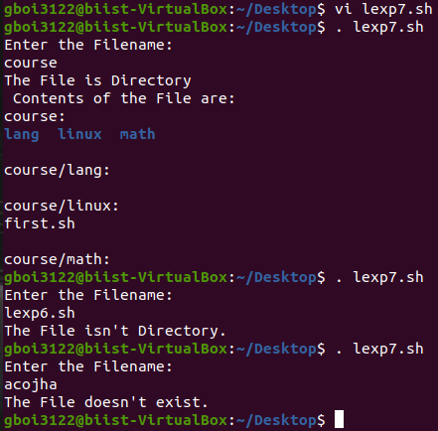

**Lab Experiment 8** **:** WAP that replaces all “.txt” file names with “.txt.old” in the current directory.

Code:

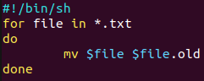

Output:

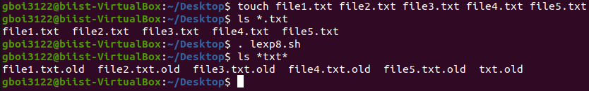

**Lab Experiment 9 :** WAP which displays the following menu and executes the option selected by the user: -  1. ls -l    2. pwd      3. ps -fe

Code:

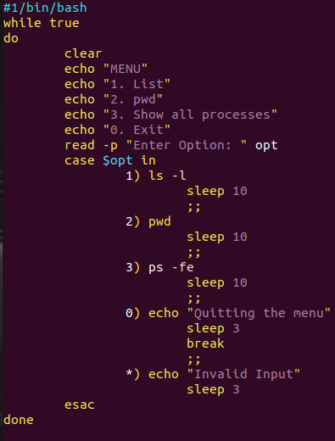

Output:

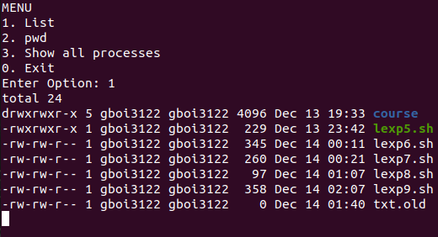

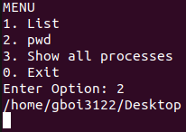

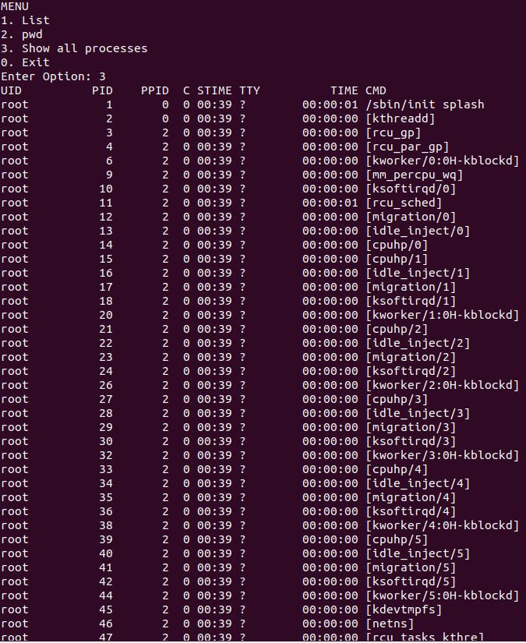

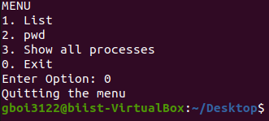

**Lab Experiment 10 :**  WAP to run a shell script, when the system starts up

* To set reminders about daily routine for a user

Code:

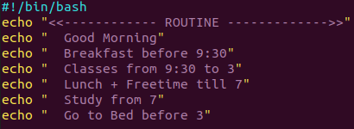



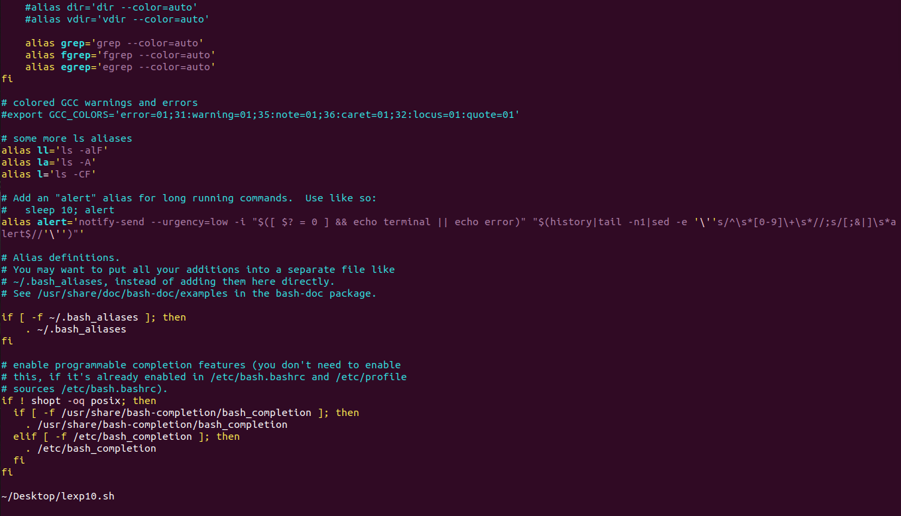

🡨

Output:

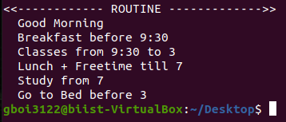

* To sort the documents in the downloads folder, based on the file extensions

Code:



Output:



-- THE END --